

License application guidelines

For right-of-way-access

In order to assist with the license application, TriMet provides the following guidelines:

Time:

- License applications should be submitted at least eight weeks in advance of anticipated access. Licenses require review by multiple TriMet departments including Real Property, Maintenance of Way, Right of Way, Engineering and Legal.
- License applications for fiber or cell towers may take up to six months, as they require FTA approval. Typically these are leases (e.g., ATT cell tower).

Submittals:

- To ensure receipt by TriMet, applications should be sent to mcneillm@trimet.org along with any supporting documentation such as drawings. Drawings should be sent in PDF format.
- Mailed applications may be sent to: TriMet Real Property
Attn: Michael McNeill 1800 SW First Ave Suite 300
Portland, OR 97201

General Design Criteria:

- Pipelines crossing underneath the light rail tracks carrying water or pressure sanitary storm sewers shall be encased.

- Pipelines and conduits, which contain flammable materials, such as gas lines, do not need to be cased. If casing pipe is installed it shall be vented and approved on a case-by-case basis by TriMet.

- Casing pipes shall be designed to withstand Light Rail Train (“LRT”) loadings and shall be protected against corrosion. The end of casing pipes shall be sealed and the annular space between the carrier pipe and the casing pipe shall be filled with sand. When casings are bored or augured under LRT tracks, provisions shall be made to ensure no voids are created.

- Minimum cover for utilities trenched under proposed LRT tracks is 6’0” below top-of-rail. Trenching is not allowed across existing LRT tracks.

- Minimum cover for utilities augured or pushed under existing LRT tracks is 7’0” below top-of-rail.

- Minimum cover for utilities directionally drilled under existing LRT tracks is 10’0” below top-of- rail.

- Where possible, all utilities shall cross beneath the LRT right-of-way at 90 degrees to the LRT centerline.

- New or replacement utilities that run longitudinally adjacent to the LRT right-of-way, unless other wise approved by TriMet, shall be located a minimum of 10’ from the centerline of track to the near edge of longitudinal pipe.

- All non-metallic LRT utilities pipes or casings shall have tone wires that terminate in a handhole to facilitate locating buried pipes.

- All abandoned pipes beneath the trackbed shall be plugged and filled with sand or controlled density fill (“CDF”) or low-strength concrete slurry, unless otherwise approved by TriMet.

- TriMet does not allow crossings or parallel systems to the Overhead Catenary System (“OCS”) on our right-of-way unless, in TriMet’s sole judgment, it is on a structure or at an elevation that allows TriMet ample room to operate and maintain the system. Clearances for anything parallel to TriMet’s system should be a minimum of 15’ from the centerline of our track. This is dependent upon the specific location that is being considered.

- TriMet does not rent space and/or allow foreign contacts on our exclusive OCS poles.

Fees:

- TriMet’s standard license application fee is $2,000.
- Additional fees may be charged for costs related to TriMet coordination, staff time, plan review, safety precautions, additional permits, transit impacts, and other necessary costs related to the project.
- TriMet may charge additional annual fees for fiber optic lines, cell towers, and other private intrusions into the Right of Way.
- Fees will be determined at the time a License Application is submitted to TriMet.

License application

For right-of-way-access

SECTION I

No.:

- Name of proposed licensee:

- Mailing address:

- City: State: Zip:

- Name of contact person:

- Phone number: E-Mail:

- Effective date desired:

- Do you now have an existing license with TriMet at this location?

- Is the application for a new facility or relocation of existing facility?

SECTION II
- Describe the proposed facility, including its purpose, location, materials and construction methods. Is this use underground, above ground or a combination? Are you aware of other existing underground facilities? NOTE: Conduit shall be bored or jacked under trackage unless otherwise approved by TriMet Engineering.

  - Length of underground crossing:

  - Depth of underground crossing:

  - Carrier pipe: Dia.: Length: Type:

  - Inner conduit: Dia.: Length: Type:

  - Wire: Size: Type: lb.
  - Crossing is located within a (check one): Dedicated street Private right-of-way

  - Please fill in the blanks corresponding to figures A and B below, or attach a separate page, or pages, in pdf form, containing all the information requested below.

    - Name of nearest MAX station on each side of proposed facility:

    - Name of street at nearest crossing:
    - Distance from proposed facility to nearest street crossing:
    - Angle at which proposed facility intersects right-of way:
    - In Figure A, north is most closely approximated by: Left Right Up Down
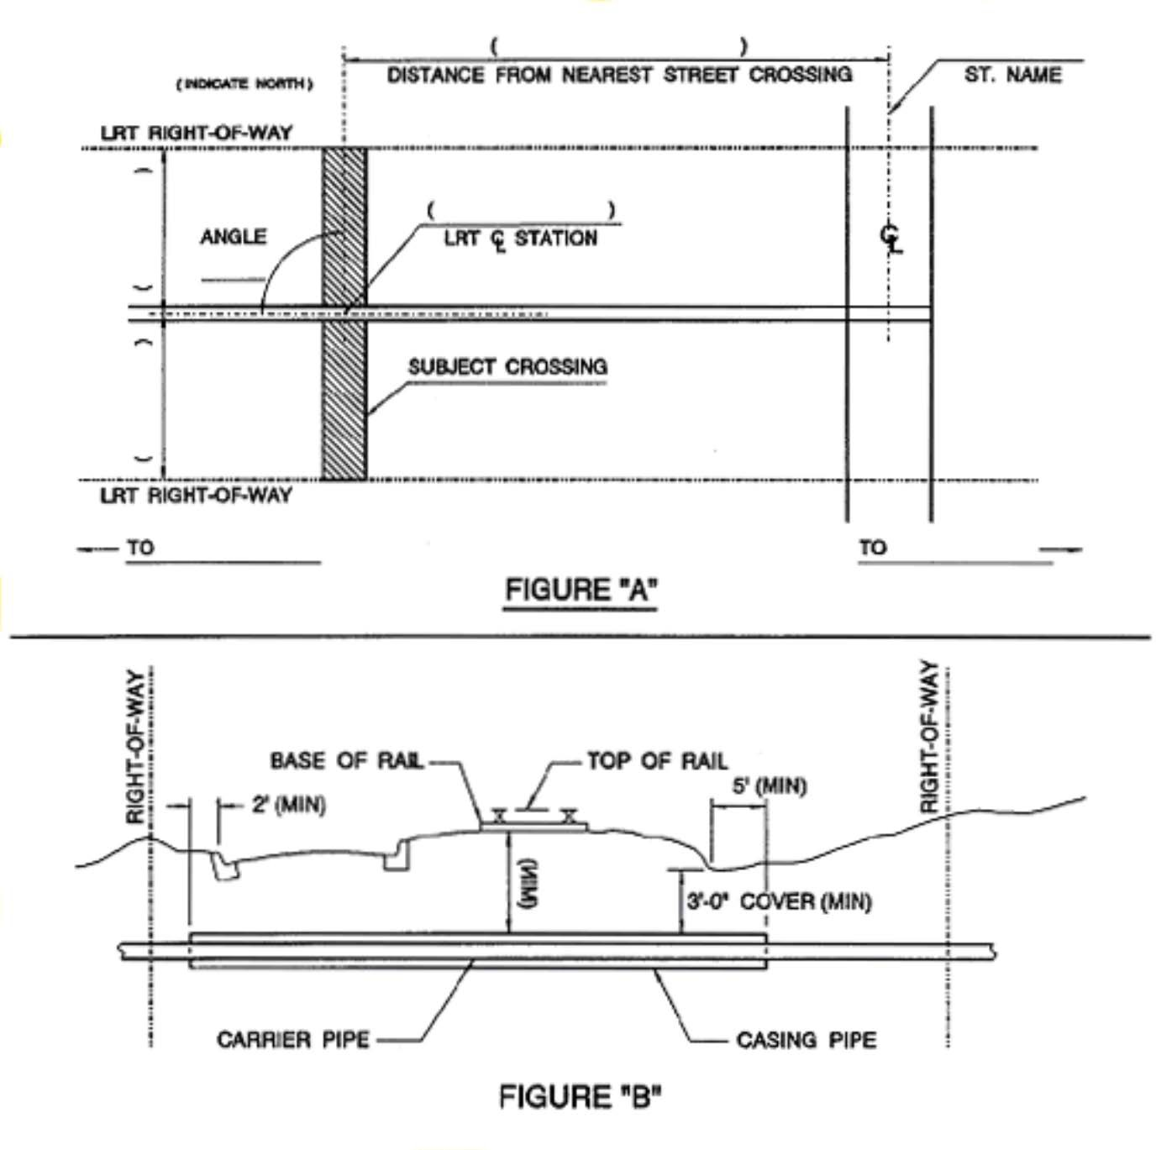

- Construction shall be performed under applicable sections of current Oregon Department of Transportation (ODOT) Standard Specifications for Highway Construction.

List the major components of the proposed work and the applicable ODOT specification section:

Section Title

- If you are drilling, jacking, or boring under our facility, what are the locations of the jacking and receiving pits (location, length, width, depth and distance from the nearest track)?

If you access our right-of-way with vehicles, where will they enter and exit?

- If you are working in the TriMet right-of-way, you must complete a “MAX Right-of-Way Access Request/Permit” after you receive your license. A copy of our current MAX Right-of-Way Access Request/Permit is included with this application.

Please note: Licensee will be required to cover any expense involved in restoring the right-of-way, including roadways.

Send completed application to:

TriMet Real Property Attn: Michael McNeill 1800 SW First Ave Suite 300
Portland, OR 97201 mcneillm@trimet.org

This page is intentionally blank,

to assure proper pagination for double-sided printing. For single-sided printing, this page can be skipped.

Permit Number:

MAX RIGHT-OF-WAY ACCESS REQUEST/PERMIT TRIMET

This Section Completed by Requesting Party:

Dates of Access: From: To:

Limits of Access:
North or Eastbound Track From: To:

Time: From: To:

South or Westbound Track From: To:

Time: From: To:

Permit Holder:

Pager: Cell:
Number of People:

Description of Work:

Equipment Required:

Requesting Party: Telephone:

Fax: Email:

CAUTION:
The overhead catenary electrical system must be considered LIVE and HOT at all times. Electrical power removal must be confirmed in the field with the designated power personnel.
This Section Completed by TriMet:

Special Operating Conditions:
  - Permits are good only for a maximum of 7 days
  - Request for Right-of-Way access permit must be submitted by 10:00 a.m. Monday, a week prior to the scheduled work.
  - All personnel must wear reflective safety vests that comply ANSI Class 2 standards.
  - Advise Control when entering and leaving the right-of-way. (Telephone 503-962-6262)
  - E-mail to johnsonj@trimet.org baccitim@trimet.org and to trackaccessrequests@trimet.org
Required: Track Access RWP Training Special Instruction: | Yes Yes | No  No |  | # Personnel: Date:  Number:
Train Order: | Yes | No
Call Boards: | Yes | No
Flags: | Yes | No
EIC: If yes check one: | Yes | No
Control
MOW
Other: (explain)
Train Flagger | Yes | No |  | Limits:
Lookout/Watchperson | Yes | No
Traffic Flagger | Yes | No
Manual Block: | Yes | No
Bus Bridge: | Yes | No
Power Removal: | Yes | No
Maintenance Advisory: | Yes |  |  | Name:
Other:

Original: Control
Copies: Permit Holder, Requesting Party, Manager of Maintenance-of-Way, System Safety, File

Request Approved:
Maintenance-of-Way Project Engineer Field Operations Track Access Coordinator

M-022B 1-19-17

